TUGAS

ORGANISASI DAN ARSITEKTUR KOMPUTER



Nama : Prames Ray Lapian

NPM : 140810210059

UNIVERSITAS PADJADJARAN

FAKULTAS MATEMATIKA DAN ILMU PENGETAHUAN ALAM

Program Studi :

TEKNIK INFORMATIKA 2022

* 1. On the IAS, describe in English the process that the CPU must undertake to read a value from memory and to write a value to memory in terms of what is put into the MAR, MBR, address bus, data bus, and control bus.

Answer:

CPU memasukkan alamat dari nilai yang dibutuhkan ke MAR untuk membaca nilai dari memori. CPU menegaskan read control line ke memori dan meletakkan alamat di addres bus. Setelah itu, memori menyalin isi lokasi memori yang diteruskan pada data bus yang nantinya akan ditransfer ke MBR. CPU memasukkan alamat ke MAR untuk menulis nilai ke memori. Setelah memasukkan alamat ke MAR, CPU memasukkan data tersebut ke dalam MBR. Lalu, CPU akan menegaskan Write Control Line ke memori dan menempatkan alamat di addres bus dan data di data bus. Lalu, memori akan mentransfer data pada data bus ke lokasi memori yang sesuai.

* 1. Given the memory contents of the IAS computer shown below,

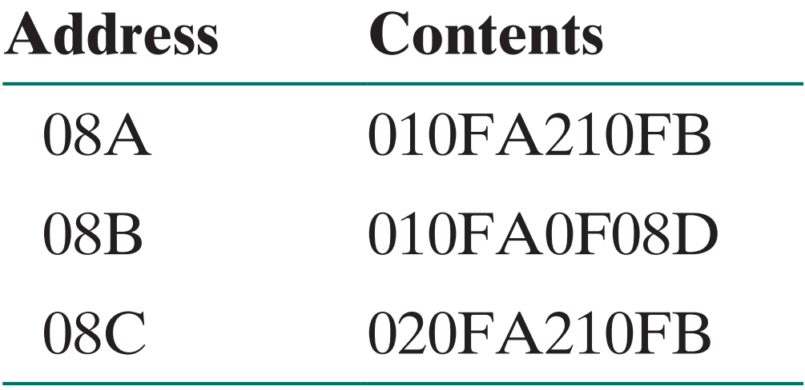

show the assembly language code for the program, starting at address 08A. Explain what this program does.

Answer:

|  |  |
| --- | --- |
| Address | Contents |
| 08A | 0FA = LOAD M  0FB = STOR M |
| 08B | 0FA = LOAD M  08D = JUMP + M |
| 08C | 0FA = LOAD – M  0FB = STOR M |

* 1. While browsing at Billy Bob’s computer store, you overhear a customer asking Billy Bob what is the fastest computer in the store that he can buy. Billy Bob replies, “You’re looking at our Macintoshes. The fastest Mac we have runs at a clock speed of 1.2 GHz. If you really want the fastest machine, you should buy our 2.4-GHz Intel Pentium IV instead.” Is Billy Bob correct? What would you say to help this customer?

Answer:

Meskipun Intel mungkin memiliki kecepatan clock yang lebih cepat (2,4 GHz vs. 1,2 GHz), itu tidak berarti sistem akan bekerja lebih cepat. Sistem yang berbeda tidak sebanding pada kecepatan clock. Faktor lain seperti komponen sistem (memori, bus, arsitektur) dan set instruksi juga harus diperhitungkan. Pengukuran yang lebih akurat adalah dengan menjalankan kedua sistem pada benchmark. Program benchmark ada untuk tugas-tugas tertentu, seperti menjalankan aplikasi perkantoran, melakukan operasi floating-point, operasi grafis, dan sebagainya. Sistem dapat dibandingkan satu sama lain tentang berapa lama waktu yang dibutuhkan untuk menyelesaikan tugas-tugas ini. Beberapa orang berpendapat, G4 sebanding atau lebih baik daripada Pentium dengan kecepatan clock yang lebih tinggi pada banyak benchmark.

* 1. A benchmark program is run on a 40 MHz processor. The executed program consists of 100,000 instruction executions, with the following instruction mix and clock cycle count:

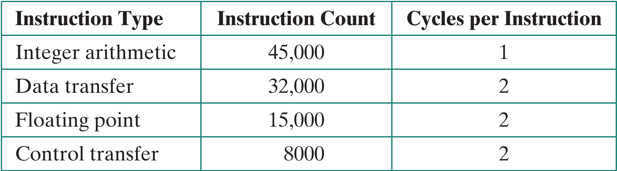

Determine the effective CPI, MIPS rate, and execution time for this program.

Answer:

* 1. Consider two different machines, with two different instruction sets, both of which have a clock rate of 200 MHz. The following measurements are recorded on the two machines running a given set of benchmark programs:

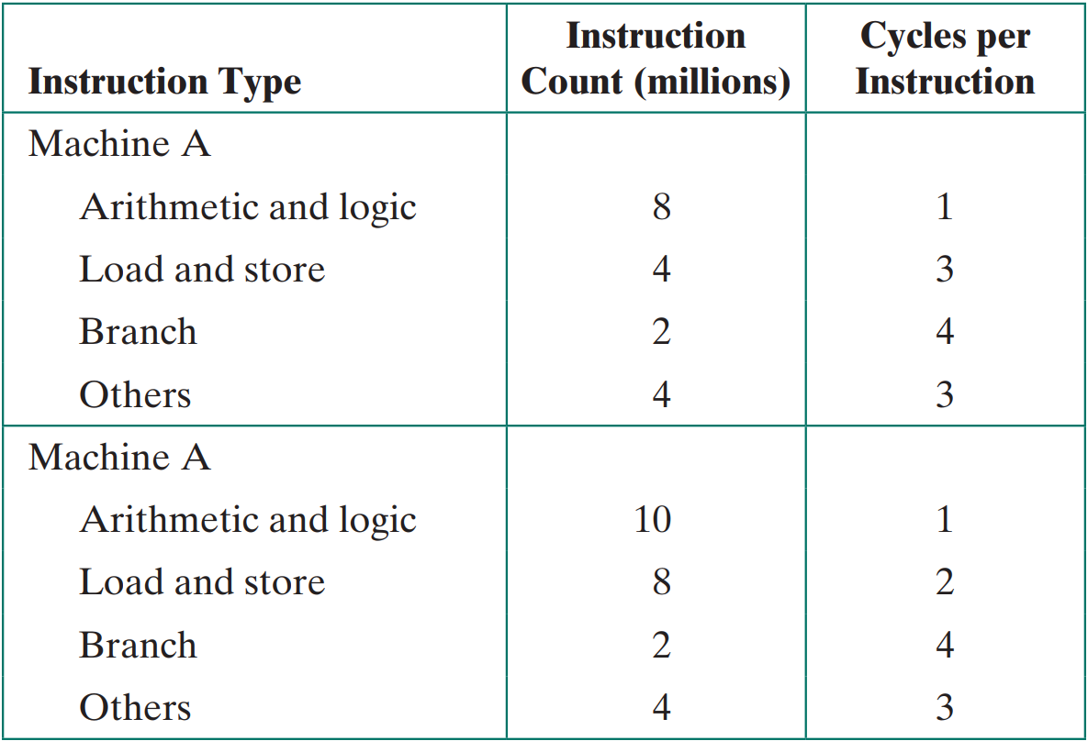

1. Determine the effective CPI, MIPS rate, and execution time for each machine.
2. Comment on the results.

Answer:

1. A
2. Walaupun mesin B memiliki MIPS yang lebih tinggi dibanding mesin A, tetapi mesin B membutuhkan CPU time yang lebih lama untuk mengeksekusi set benchmark program yang sama.

* 1. Early examples of CISC and RISC design are the VAX 11/780 and the IBM RS/6000, respectively. Using a typical benchmark program, the following machine characteristics result:

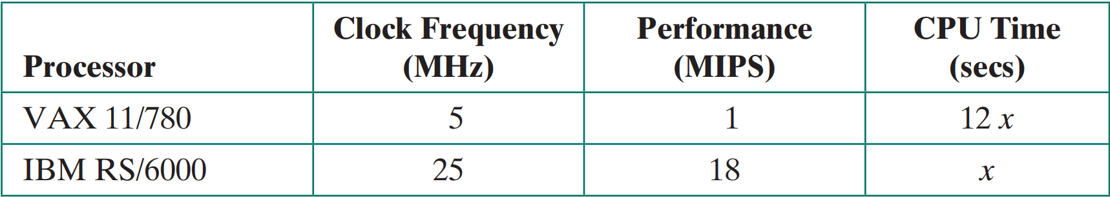

The final column shows that the VAX required 12 times longer than the IBM measured in CPU time.

1. What is the relative size of the instruction count of the machine code for this benchmark program running on the two machines?
2. What are the CPI values for the two machines?

Answer:

1. A
2. B
   1. Four benchmark programs are executed on three computers with the following results:

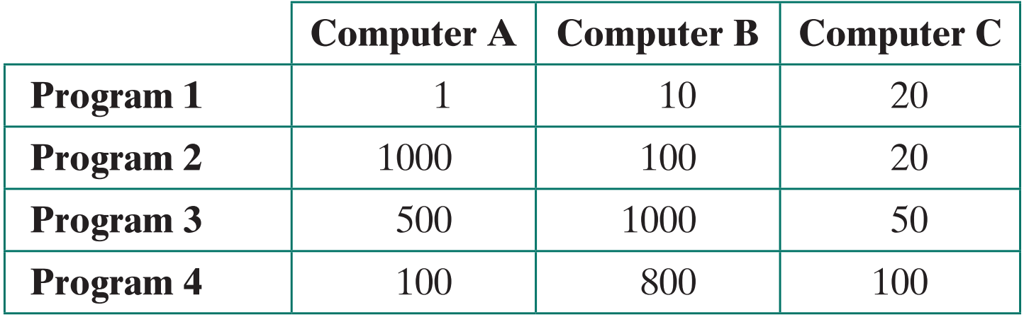

The table shows the execution time in seconds, with 100,000,000 instructions executed in each of the four programs. Calculate the MIPS values for each computer for each program. Then calculate the arithmetic and harmonic means assuming equal weights for the four programs, and rank the computers based on arithmetic mean and harmonic mean.

Answer:

MIPS = IC / (T × 106 ) = 100/T

|  |  |  |  |
| --- | --- | --- | --- |
|  | **Computer A** | **Computer B** | **Computer C** |
| **Program 1** | 100 | 10 | 5 |
| **Program 2** | 0,1 | 1 | 5 |
| **Program 3** | 0,2 | 0,1 | 2 |
| **Program 4** | 2 | 0,125 | 1 |

Arithmetic Mean Rank = Jumlah semua MIPS dibagi banyaknya program.

Computer A = 25.575 --- 1

Computer B = 2.8 --- 3

Computer C = 3.25 --- 2

Harmonic Mean Rank = Banyaknya program dibagi $\frac{1}{MISP1}+ \frac{1}{MISP2}+…$

Computer A = 0.25 --- 2

Computer B = 0.21 --- 3

Computer C = 2.1 --- 1

* 1. The hypothetical machine of Figure 3.4 also has two I/O instructions:

**0011 = Load AC from I/O**

**0111 = Store AC to I/O**

In these cases, the 12-bit address identifies a particular I/O device. Show the program execution (using the format of Figure 3.5) for the following program:

1. Load AC from device 5.
2. Add contents of memory location 940.
3. Store AC to device 6.

Assume that the next value retrieved from device 5 is 3 and that location 940 contains a value of 2.

Answer:

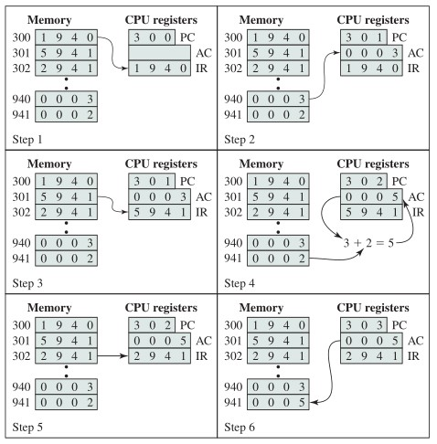

* 1. IR - 3005
* AC - 3
* IR - 5940
* AC - 5 = 3+2
* IR - 7006
* Device - AC
  1. The program execution of Figure 3.5 is described in the text using six steps. Expand this description to show the use of the MAR and MBR

Answer:

